Week 3 Assignment – Lab 3: Deploy Tiny Linux VM (B1s) with Nginx via Cloud-Init
Name: Amrish Kumar
Assignment: Week 3 – Lab 3
Topic: Tiny Linux VM (B1s) with Nginx using Cloud-Init
Platform: Microsoft Azure

1. Objective
The objective of this lab is to create a lightweight virtual machine (B1s size) in Microsoft Azure, deploy the Nginx web server automatically during VM provisioning using a cloud-init configuration, and verify successful installation and access via a web browser.

2. Definition and Purpose
Tiny Linux VM (B1s): A B1s VM in Azure is part of the “Burstable” series, designed for workloads that do not require continuous high CPU performance. It provides cost efficiency for small web servers, testing environments, or learning purposes.
Cloud-Init: Cloud-init is a tool used to automate the initial configuration of a Linux VM. It allows users to run scripts, install packages, and set up configurations during the first boot of the virtual machine. This eliminates the need for manual setup after deployment.
Nginx Web Server: Nginx is an open-source web server known for its high performance, scalability, and low resource usage. It is commonly used for serving static content, acting as a reverse proxy, and load balancing.

3. Steps Performed

Step 1: Create a Resource Group
1. Open Azure Portal.
2. Navigate to Resource Groups → Create Resource Group.
3. Provide a name (e.g.,yc-18122) and select a region (e.g., East US).
4. Click Review + Create → Create.

Step 2: Prepare Cloud-Init Script
Create a file named cloud-init.txt with the following content:
- #cloud-config
package_update: true
packages:
- nginx
runcmd:
- systemctl enable nginx
- systemctl start nginx
Explanation:
- package_update: true – Updates the package list on the VM.
- packages: Installs Nginx automatically.
- runcmd: Ensures Nginx service starts and is enabled on boot.
Attach Screenshot 2: cloud-init file.

Step 3: Create the Virtual Machine
1. Go to Azure Portal → Virtual Machines → Create → Azure Virtual Machine.
2. Fill in the required details:
- Resource Group: rg-vivek-linux-lab3
- VM Name: vm-vivek-nginx
- Region: East US (or your preferred)
- Size: B1s
- Authentication: SSH key or Password
3. In the Advanced tab, upload the cloud-init.txt file under Custom Data.
4. Review and Create the VM.
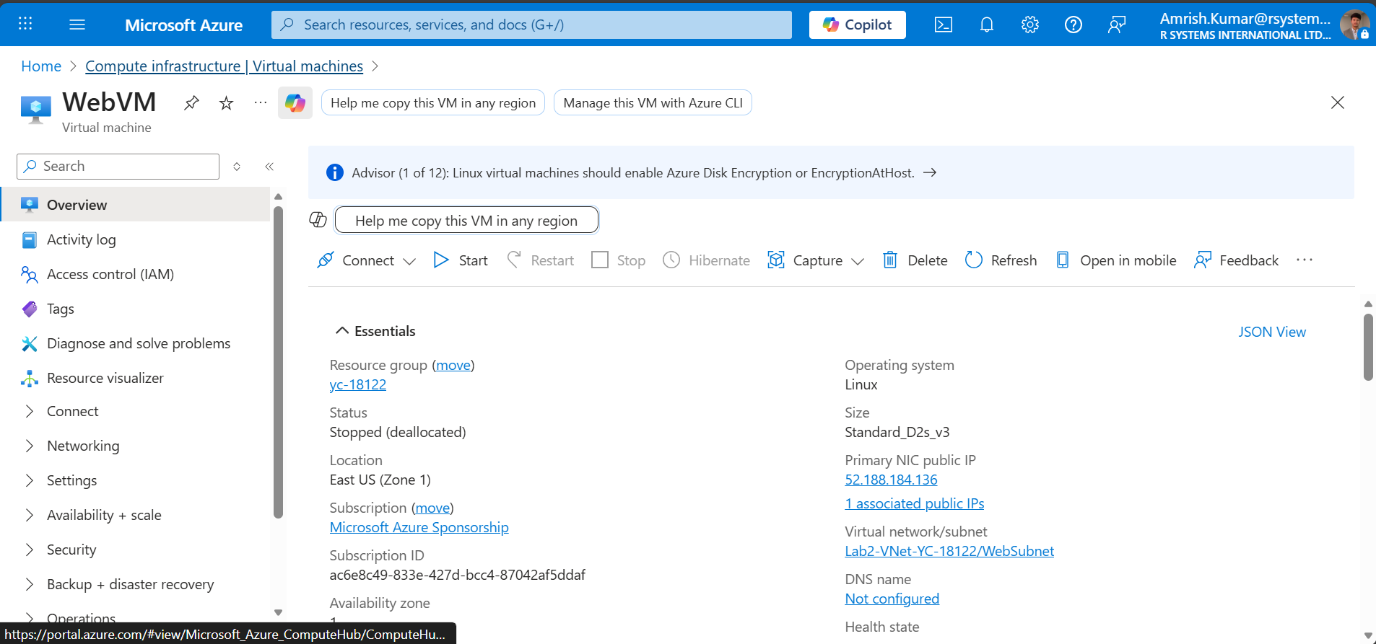

Step 4: Verify Deployment
Once the deployment completes:
- Go to the Virtual Machine → Overview page.
- Copy the Public IP Address.
- Open a terminal and connect via SSH:
ssh azureuser@<Public-IP>
- Check Nginx status:
systemctl status nginx

Step 5: Test Nginx Web Server
1. Open a web browser.
2. Enter the VM’s public IP address.
3. You should see the default Nginx welcome page, confirming successful deployment.

4. Result / Output
- Successfully created a Tiny Linux VM (B1s).
- Cloud-init automatically installed and started Nginx.
- Verified web access to the Nginx default page.

5. Conclusion
In this lab, a lightweight Linux VM was deployed and configured automatically using a cloud-init script. This demonstrates Infrastructure as Code (IaC) concepts, allowing faster and consistent provisioning without manual intervention. The result is a fully functional Nginx web server ready for use.

